Nana Kwame Baah

POS 604: Quantitative Methods

Dr. Meserve

**Assignment 3 response**

**Question 1**

The correlation is 0.9860926. which is a high positive correlation. This is near 1 which means when that compensation results in high productivity among workers. The increase in productivity in near a 100 percent. Firms and business owners will have increase productivity with an increase in compensation. Since the relationship is high and response the compensation should not be too high to cause productivity change. I unit increase in compensation of business will lead to a 98 percent increase in productivity.

**Question 2**

After running the regression, the intercept was -102.366 and the coefficient was 1.992 Using the equation of a line, I formulate a relationship between business compensation (independent variable x) and business productivity (dependent variable y) as;

Y = -102.366 + 1.9X

Talk about the slope.

The slope of the regression line is 0.0116.  For  each additional foot of depth we start drilling, the  time to drill five feet increases by 0.0116 minutes,  on average.

From the equation, compensation has a positive relationship with productivity in the business sector. The coefficient of compensation (x) is 0.488 and it shows a correlation between the compensation and productivity.

For a 5-point index increase will lead to a 5 percent increase in the real GDP in America than the value 100 for 1992.

Mathematically, when we substitute the 5-point index increase in hourly compensation in the model we have;

Y = 52.336 + 0.488 (5)

Y = 52.336 + 2.44

Y = 54.776

So, a 5-point increase results in increase in real GDP in America by 54.776 in terms of baseline year 1992. And the total increase in productivity will be 154.776 compared to the base value.

For a 12-point index increase in compensation will lead to a 12 percent increase in the real GDP in America than the base value 100.

Mathematically, when we substitute the 12-point index increase in hourly compensation;

Y = 52.336 + 0.488 (12)

Y = 52.336 + 5.856

Y = 58.192

The real GDP of America will increase by 58.192. The total increase is 158.192 more than the base value 100.

**Question 3a**

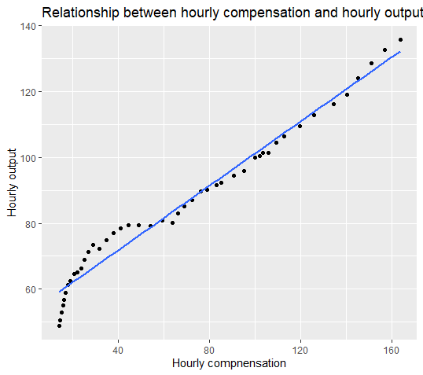

**Question 3b**

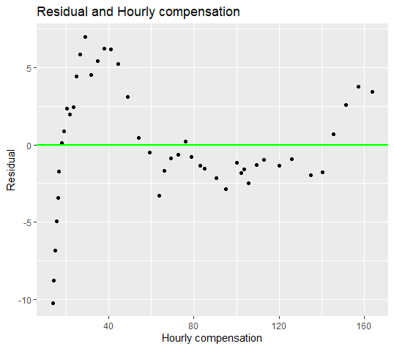

**Question 4**

**Question 5**

**R- squared = 0.9708 nonfarm**

**This means that 97 percent of the variation in the productivity can be explained by hourly compensation provided in the nonfarm sector.**

**R squared = 0.9724 business**

**This means that 97 percent of the variation in the productivity of the variation in the hourly productivity in the business sector can be explained by hourly compensation provided in the business sector.**

**Question 6**

Intercept = 54.756, X = 0.468

Y = 54.756 + 0.468 X



Equation of a line

yˆ = b 0 + b 1 x

correlation. This is near 1 which means when that compensation results in high productivity among workers. The increase in productivity in near a 100 percent. Firms and business owners will have increase productivity with an increase in compensation. Since the relationship is high and response the compensation should not be too high to cause productivity change. I unit increase in compensation of business will lead to a 98 percent increase in productivity.

productivitybusiness---output per hour of all persons in entire business sector (real GDP output)

productivitynonfarm---ouput per hour of all persons in business sectors excluding farming

compensationbusiness---hourly compensation of all persons in entire business sector

compensationnonfarm---hourly compensation of all persons in business sectors excluding farming

**Question 2**

With coefficient 0.488 and intercept 52.336 is formulate a relationship between business compensation (independent variable x) and business productivity (dependent variable y) as

Y = 52.336 + 0.488x

A unit change in hourly compensation will results in 0.488 change in business productivity. There is a positive relationship between business compensation and business productivity.

For a 5 index increase in hourly compensation,

Y = 52.336 + 0.488 (5)

Y = 52.336 + 2.44

Y = 54.776

A five index increase in the hourly compensation leads to an increase in productivity by 54.776.

When the index increase is by 5 points

Y = 52.336 + 0.488 (12)

Y = 52.336 + 5.856

Y = 58.192

productivitybusiness---output per hour of all persons in entire business sector (real GDP output)

productivitynonfarm---ouput per hour of all persons in business sectors excluding farming

compensationbusiness---hourly compensation of all persons in entire business sector

compensationnonfarm---hourly compensation of all persons in business sectors excluding farming